2005 WSASEA Spring Conference

April 18th – April 20th ---- Rainbow Lodge, North Bend, WA

Student Employment Administrators are encouraged “Follow the Yellow Brick Road to Student Employment Success” at the 2005 Spring Conference. Whether you’re searching for improved communication skills, I-9 form requirements or special event planning tips, you will find this and more in the land of WS-OZ-EA. The WSASEA Conference Planning Committee is pleased to present the following information related to the 2005 conference.

Conference Begins: Conference Ends:
10:00 a.m. – Monday, April 18th 12:00 p.m. – Wednesday, April 20th

Schedule of Events

Monday, April 18th

10:00 – 11:30 Registration and Room Assignment

11:30 – 12:00 WSASEA Newcomer Table
If this is your inaugural trip to the WSASEA Spring Conference (and even if it is not), use this opportunity to get acquainted with the WSASEA executive board and other members.

12:00 – 1:00 Lunch

1:00 – 1:30 WSASEA Meet and Greet

1:30 – 3:30 Employing “Generation Why?” - Keynote Speaker: Eric Chester
Nobody in America has a better understanding of Generation Why than Eric Chester. This exciting and revealing presentation will give you an in-depth look at the 40 million gen. whys. Understand how their values affect their approach to the workplace.

3:45 – 5:15 HECB Update: Betty Gebhardt, Khris Blumer, Jeffrey Powell and Juliette Knight

5:30 – 6:30 Dinner

6:30 – 7:30 Movie and Popcorn Night - Nickled and Dimed video (optional)
Essayist Barbara Ehrenreich committed most of two years to working minimum wage jobs in an attempt to make ends meet. In the process, she experiences a world where civil liberties are often ignored and hard work fails to live up to its reputation as the ticket out of poverty. This movie, based on a book by the same name, recounts her experiences. Join us for this movie and discussion.

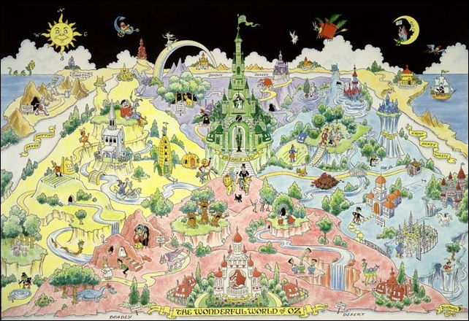

Tuesday, April 19^{9h}

7:30 – 8:30 Breakfast

8:30 – 8:45 WSASEA Executive Board Introduction

8:45 – 10:00 Round Table Discussion: Gayle Dohrman
Come prepared with issues that you would like to discuss with other members. This is an excellent opportunity to share best practices and to ask questions that specifically relate to your student employment program.

10:15 – 12:00 The Shocking Truth about Education -Working, Living,
Learning and Earning in America: Dr. Susan Quattrociocchi
Dr. Q uses a unique blend of common sense, wit, and humor as she addresses the topic of Living, Learning and Earning in America. Dr. Q is an Associate in the Center for Learning Connections at Bellevue Community College.

12:00 – 1:00 Lunch

1:00 – 2:30 Student Employment Jeopardy: Bob Yohnka
Brush up on the federal & state work-study regulations. Student Employment Jeopardy will amusingly test your knowledge in a broad range of topics.

2:45 – 4:00 Special Events Panel - Job Fairs and SEOTY: Selected Washington State College and University Representatives
Your colleagues across the state are excellent resources when planning special events on your campus. If you are interested in hosting a job fair, training session, or a student employee celebration but don’t have the money, time or man power…learn the “ins and outs” from other members.

4:15 – 5:30 FERPA Training: Gayle Dohrman and Eryn Pearson
Make sure your student employment program adheres to the Family Educational Rights to Privacy Act. Specific requirements and ideas for instituting training programs will be discussed

5:30 – 6:30 Dinner

6:30 - ? Social Activities (See the attached list of potential activities)



Wednesday, April 20^{9h}

7:30 – 8:30 Breakfast

8:30 – 9:30 Student Employment Case Studies: Bob Yohnka
Apply your student employment knowledge to these real life case studies. Work with others to address tricky and troublesome issues that could potentially arise on your campus.

9:30 – 10:00 House Keeping
Overnight guests are encouraged to use this time to tidy their rooms. WSASEA is assessed a fee for each room that is not cleaned. Single-day attendees are encouraged to meander the grounds of Rainbow Lodge.

10:00 – 12:00 Understanding the Form I-9 and Social Security Requirements: Lynda Buehring, Dept of Homeland Security & Tim Beard, Social Sec. Admin.
This is your chance to get the facts associated with the I-9 and Social Security issues. Lynda Buehring and Tim Beard will provide valuable information regarding fraudulent documentation and will take time to answer questions related to these issues.

12:00 WSASEA 2005 Spring Conference Adjourns
Make plans to be at our next gathering! The WSASEA Town Meeting will be held at Central Washington University in Ellensburg on November 4, 2005.

WSASEA Community Service Project

WSASEA is pleased to name Nativity House as our community service project this year.

Nativity House is a Christian sponsored drop-in center for the homeless community of
Tacoma, WA. They offer a refuge from the dangers of the streets to all who come to their doors. Whether their guests need a meal, clothing, referrals to social services or just a smile, the staff at Nativity House is there to provide it. Their mission is to create trusting relationships with their guests, so that they may be challenged to greater life.

Your contribution will be greatly appreciated and may include toothpaste/toothbrushes; sample sizes of shampoo and conditioner; soap; lotion; hats and mittens; small fold-up ponchos; books; puzzles. Please participate in our community service project by making a donation at the 2005 Spring Conference. Executive Board members will deliver items to Nativity House the following week. To learn more about Nativity House, visit their website at www.nativityhouse.org.



REMINDERS!!!!!

What to bring?

- Your own towel and bath items (this is a very nice, but rustic retreat setting – towels are not provided and shared bathrooms are in the hall).

- Dress is casual. Be prepared for cool, damp weather. Bring sturdy shoes if you plan to scale Mt. Si.

- Snacks for the common good and movies (there’s a VCR and a big-screen TV). An always-open soda fountain is available for soft drinks as part of your conference fee. A refrigerator is available for you to store perishable snacks or beverages including beer and wine for after hours socializing.

- Credit card, money or checkbook for shopping at the factory outlet stores in North Bend. If you would rather “hike” the mall than up Mt. Si.

- Items to share or display for the resource table. Helpful items include:

  - Handbooks
  - Job Location and Development items
  - Sample forms, brochures or other promotional items or anything that might be valuable to other institutions about how you d o your job.

The WSASEA Executive Board will be providing a table with literature from different job software companies. We encourage schools collect information for their institution if seeking assistance with selecting a system that fits their campus.



Social Activities

- Climb Mt. Si:
Minutes from the Rainbow Lodge is Mt. Si. You may climb up one of the many trails. The steep four-mile climb to Mt. Si is very popular, with summit views of the surrounding mountains and Mt. Rainier. Make sure you have a good pair of shoes with traction soles; anything with hard, smooth bottoms will have you sliding down the trail. For additional information, check out the website at http://www.mountsi.com/.

- Campfire:
There is a great area to build a campfire, so bring marshmallows, graham crackers and chocolate bars for s’mores. You may bring a guitar if you play for singing campfire songs or a few humorous tales from the world of student employment to share.

- Movies:
There is a big screen TV provided with a VCR for movies. Bring movies you might want to share with the group.

- Games:
Rainbow Lodge does have a selection of games to play, but bring your own for a fun night.

- Factory Stores at North Bend:
Check out the factory outlet in North Bend, WA. For additional information, visit their website at
http://www.premiumoutlets.com/outlets/outlet.asp?id=49.



Driving Directions

Driving Directions to Rainbow Lodge

Traveling from Western Washington:

- Take I-90 to Exit 32 (436th Street).

- Take 436th back over I-90 until it dead-ends (North Bend Way).

- Turn left and then take the first right onto Mt. Si Road. Stay on Mt. Si Road for three miles.

- Look for the Rainbow Lodge sign on your left just after you pass 468th Street.

Traveling from Eastern Washington:

- Take I-90 to Exit 32 (436th Street).

- Turn right on 436th and follow it until it dead ends (North Bend Way).

- Turn left and then take the first right onto Mt. Si Road. Stay on Mt. Si Road for three miles.

- Look for the Rainbow Lodge sign on your left just after you pass 468th Street.

Please visit www.wsasea.org for additional 2005 Spring Conference or general WSASEA information.



